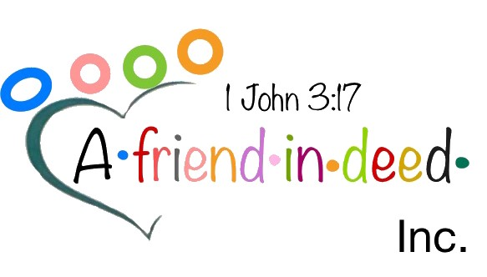
Hi, My name is Ronald D. Patterson Jr.
I am the CEO and President of A friend in Deed Incorporated a brand new non-profit Charitable organization in Dayton, Ohio. As part of our mission. We help employers increase their work force by connecting them to employees who do not have reliable transportation. In the past, employers would not offer employment to anyone who does not have their own reliable transportation no matter how hardworking or dependable they are. Things are changing due to our incentivized employee Pick Me Up program which provides transportation to and from work. Our program allows employers to add needed employees to their workforce while costing the employer nothing for employee transportation.
Employers quickly realize that the fees collected through the company’s HR department and the Pick Me Up program allows the program to pay for itself. For companies struggling to find and keep employees. Contracted transportation services are the way to go. They can remove transportation as a barrier to employment, improve a company’s bottom line in terms of production, decrease crime, increase the tax base from working citizens while also creating healthy self-sufficient families. With contracted transportation services from A Friend in Deed Incorporated everyone wins.
In the coming months we will make our Corporate Pick Me Up program available to Corporate partners and any human resource department who wishes to participate. The Pick Me Up program creates a win situation for employers looking to add to their thin workforce and employees who desire to return to the workforce despite not having reliable transportation.
If you would like to become a corporate partner and would like more information on how to increase your workforce with our Pick Me UP program. Please feel free to contact A Friend Indeed Incorporated.
Ronald D. Patterson Jr at afriendndeedinc@gmail.com 937-623-8804

